Report

Big Mountain Resort services approximately 350,000 people annually. The Resort is serviced by 11 chair lifts, 2 T-bars, and 1 magic carpet for novice skiers. It has a base elevation of 4,464 ft with a summit elevation of 6,817 ft making for a 2,353 ft vertical drop with a longest run of 3.3 miles. The resort has recently installed a chair lift increasing the operating costs for this season by $1,540,000.

Historically, Big Mountain Resort’s pricing strategy has been to charge a premium above the average price of resorts in its market share. There are limitations to this approach, and it does not allow Big Mountain to fully capitalize on its facilities. So, Data analysis has been undertaken using a Random Forest model on available data from Resorts in Big Mountain’s market share. A summary of the features available for analysis is provided here.

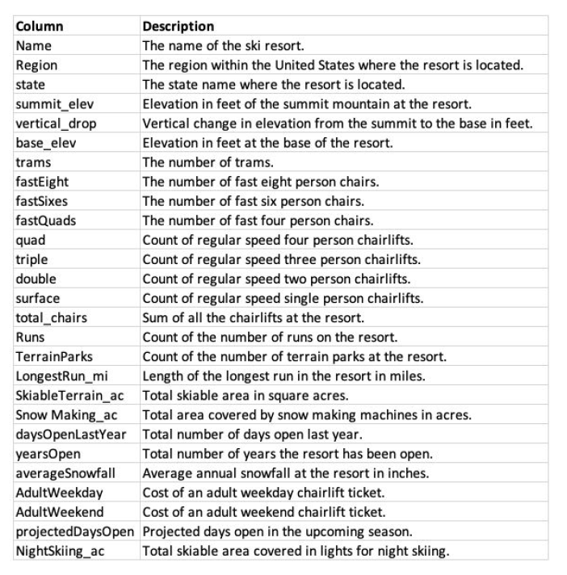

Data was cleaned prior to applying the model, and entries with incomplete data were removed.

Big Mountain Resort modeled price is $95.87, actual price is $81.00. Even with the expected mean absolute error of $10.39, this suggests there is room for an increase. There are however concerns about the validity of the model since Big Mountain seems to be incorrectly pricing its tickets other resorts may be as well. However given the difference between the predicted an actual price is well outside the mean absolute error, some price increase is warranted.

It is best to avoid closing runs as that is only predicted to decrease ticket price, and therefore revenue, without any noteworthy benefits as shown in the figure below. Note: There the revenue drop is in millions ($1,000,000s).

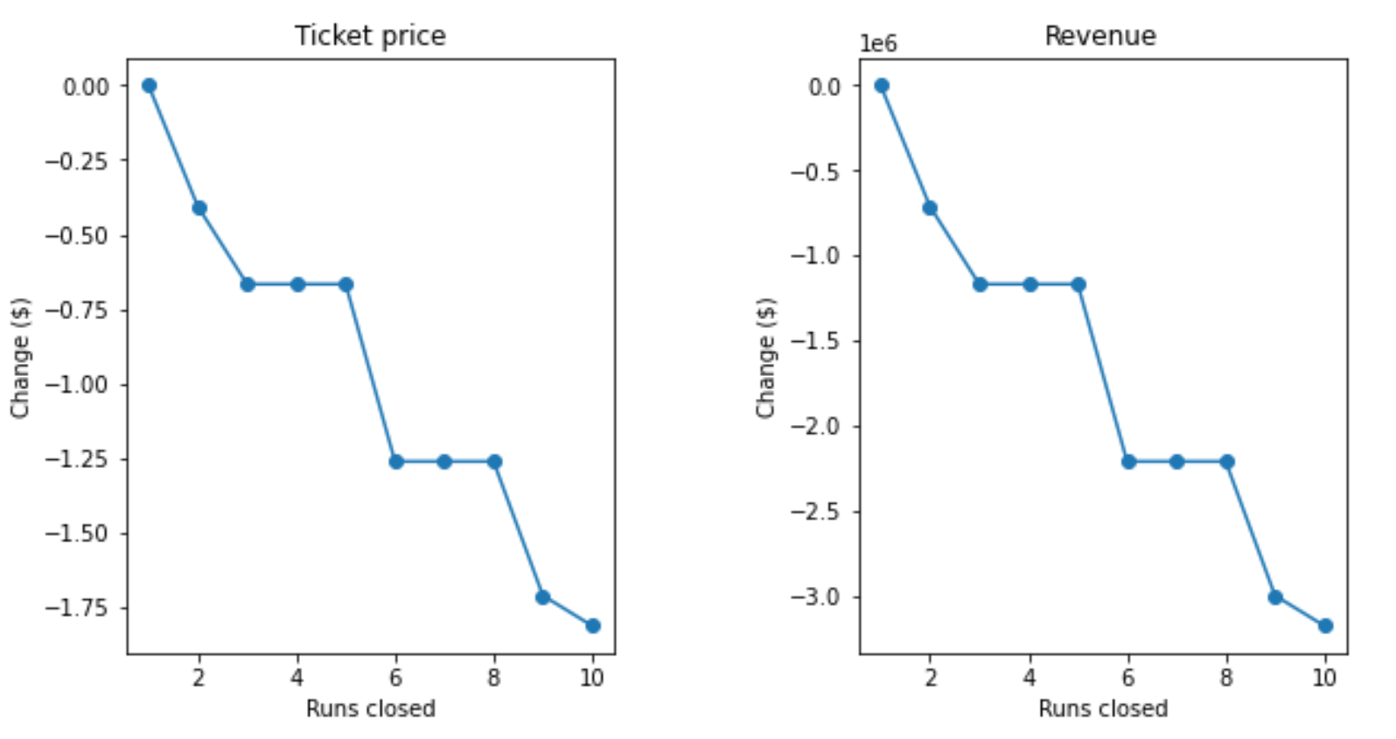

Adding a new run with a chair lift to increase the vertical drop by 150ft increases support for ticket price by $1.99. Over the season, this could be expected to amount to $3,474,638 in additional revenue. Adding additional snow making acreage is not predicted to have any impact on ticket price nor is increasing the length of the longest run, so it is not recommended to go forward with these plans.

As a final recommendation, I suggest adding the new run as discussed above and then increasing the ticket price by $6.00. With the new run, there is room to increase the ticket price by as much as $6.47, before we are within the range of the mean error, but it might be desirable to keep the price in whole dollar amounts as it is currently. Closing runs